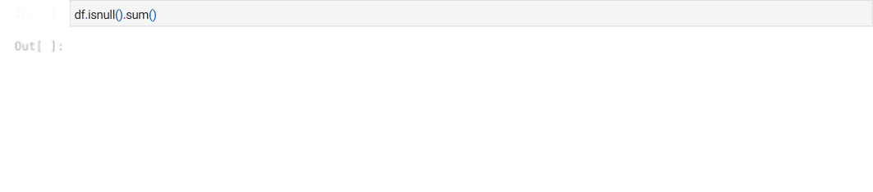

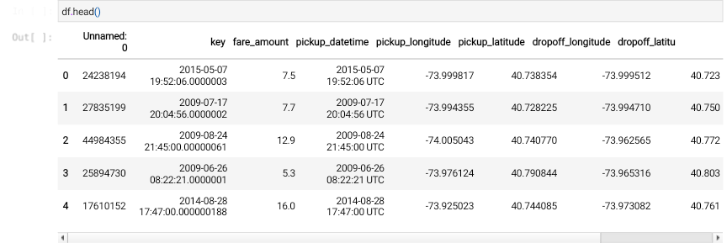

<class 'pandas.core.frame.DataFrame'> RangeIndex: 200000 entries, 0 to 199999 Data columns (total 9 columns):

# Column Non-Null Count Dtype



1. Unnamed: 0 200000 non-null int64
2. key 200000 non-null object
3. fare_amount 200000 non-null float64
4. pickup_datetime 200000 non-null object
5. pickup_longitude 200000 non-null float64
6. pickup_latitude 200000 non-null float64
7. dropoff_longitude 199999 non-null float64
8. dropoff_latitude 199999 non-null float64
9. passenger_count 200000 non-null int64 dtypes: float64(5), int64(2), object(2) memory usage: 13.7+ MB



1. Pre-process the dataset.

| Unnamed: 0 | 0 |
| --- | --- |
| key | 0 |
| fare_amount | 0 |
| pickup_datetime | 0 |
| pickup_longitude | 0 |
| pickup_latitude | 0 |
| dropoff_longitude | 1 |
| dropoff_latitude | 1 |
| passenger_count | 0 |
| dtype: int64 |  |



Unnamed: 0 0

key 0

fare_amount 0

pickup_datetime 0

pickup_longitude 0

pickup_latitude 0

dropoff_longitude 0

dropoff_latitude 0

passenger_count 0

dtype: int64

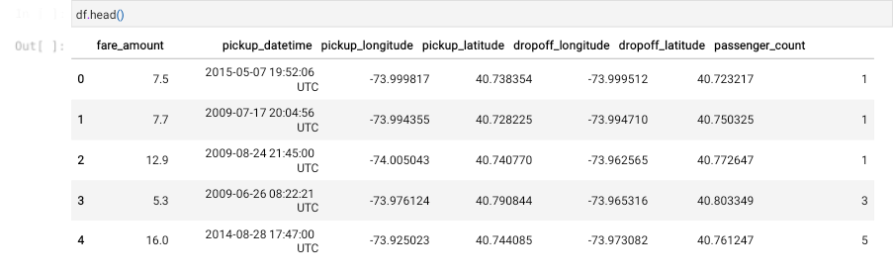

| df**.**dtypes |  | | | | | |
| --- | --- | --- | --- | --- | --- | --- |
| fare_amount pickup_datetime pickup_longitude pickup_latitude dropoff_longitude dropoff_latitude passenger_count dtype: object | float64 object float64 float64 float64 float64 int64 |  |  |  |  |  |
| df**.**describe() |  |  |  |  |  |  |
| **fare_amount** | **pickup_longitude** | **pickup_latitude** | **dropoff_longitude** | **dropoff_latitude** | **passenger_count** |  |
| **count** 199999.000000 | 199999.000000 | 199999.000000 | 199999.000000 | 199999.000000 | 199999.000000 |  |
| **mean** 11.359892 | -72.527631 | 39.935881 | -72.525292 | 39.923890 | 1.684543 |  |
| **std** 9.901760 | 11.437815 | 7.720558 | 13.117408 | 6.794829 | 1.385995 |  |
| **min** -52.000000 | -1340.648410 | -74.015515 | -3356.666300 | -881.985513 | 0.000000 |  |
| **25%** 6.000000 | -73.992065 | 40.734796 | -73.991407 | 40.733823 | 1.000000 |  |
| **50%** 8.500000 | -73.981823 | 40.752592 | -73.980093 | 40.753042 | 1.000000 |  |
| **75%** 12.500000 | -73.967154 | 40.767158 | -73.963658 | 40.768001 | 2.000000 |  |
| **max** 499.000000 | 57.418457 | 1644.421482 | 1153.572603 | 872.697628 | 208.000000 |  |

1. Identify outliers.

OUTLIER: An object that deviates significantly from the rest of the objects.

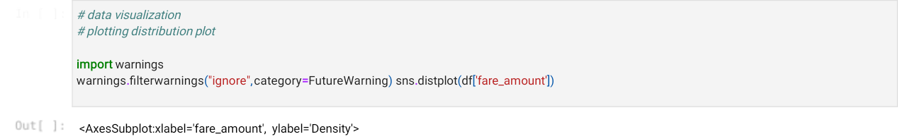

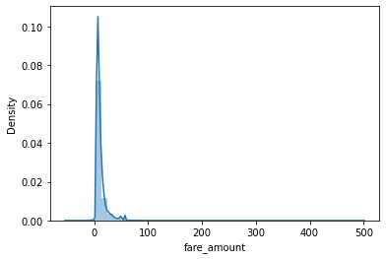

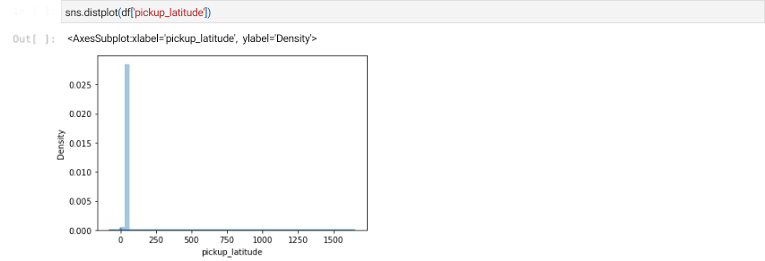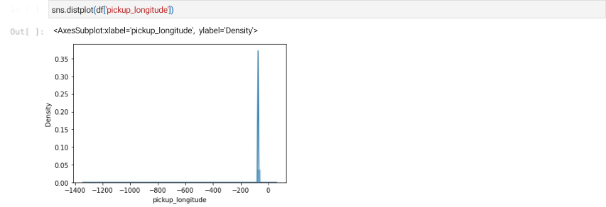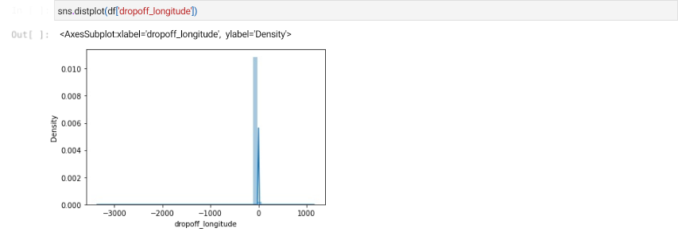

<AxesSubplot:xlabel='dropoff_latitude', ylabel='Density'>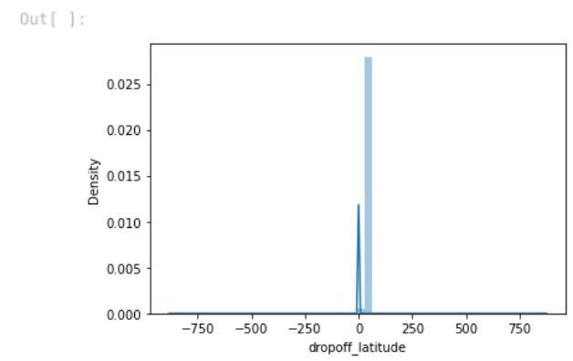

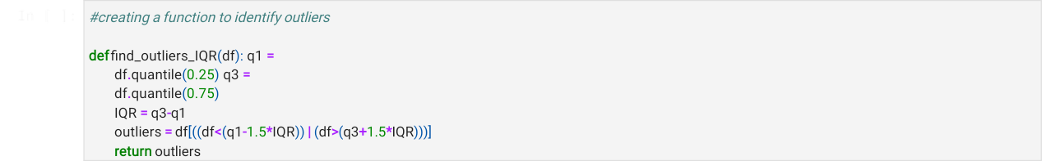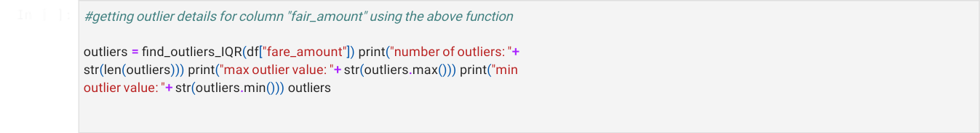

number of outliers: 17166 max outlier value: 499.0 min outlier value: -52.0

| 6 | 24.50 |
| --- | --- |
| 30 | 25.70 |
| 34 | 39.50 |
| 39 | 29.00 |
| 48 | 56.80 |
|  | ... |
| 199976 | 49.70 |
| 199977 | 43.50 |
| 199982 | 57.33 |
| 199985 | 24.00 |
| 199997 | 30.90 |

Name: fare_amount, Length: 17166, dtype: float64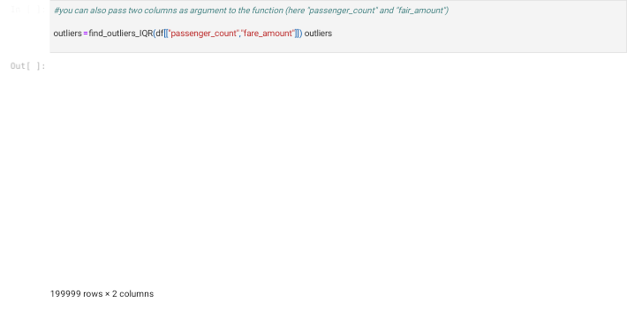

|  | **passenger_count** | **fare_amount** |
| --- | --- | --- |
| **0** | NaN | NaN |
| **1** | NaN | NaN |
| **2** | NaN | NaN |
| **3** | NaN | NaN |
| **4** | 5.0 | NaN |
| **...** | ... | ... |
| **199995** | NaN | NaN |
| **199996** | NaN | NaN |
| **199997** | NaN | 30.9 |
| **199998** | NaN | NaN |
| **199999** | NaN | NaN |





41.06517154774204

-18.3453884488253

1. Check the correlation.

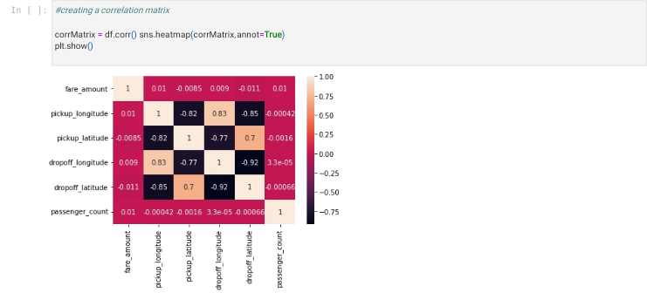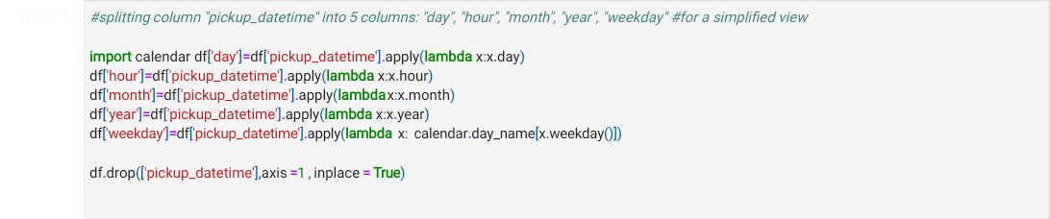

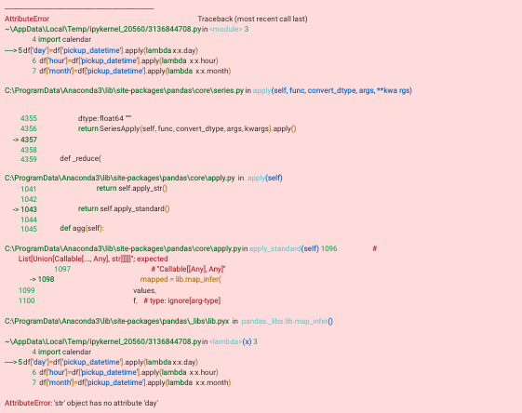



1. Implement linear regression and random forest regression models.
2. Evaluate the models and compare their respective scores like R2, RMSE, etc.



Predict the price of the Uber ride

